**Integrating Blockchain for Advanced Supply Chain Solution**

Gajjela Stevenson, Neelagiri Chandradeep, Dr. Pallam Ravi, Rathlavath Rajesh

U.G. Student, Department of CSE, Anurag University, Hyderabad Telangana, India

U.G. Student, Department of CSE, Anurag University, Hyderabad Telangana, India

Associate Professor, Department of CSE, Anurag University, Hyderabad Telangana, India

U.G. Student, Department of CSE, Anurag University, Hyderabad Telangana, India

**ABSTRACT**: This study suggests a novel way to use blockchain technology to improve supply chain information exchange. We outline techniques for incorporating blockchain technology into supply chain management, such as using blockchain to share information within the supply chain, creating a supply chain architecture for production companies based on blockchain technology, and utilizing a hierarchical model to control the flow of information within the supply chain. The study presents an information block recording technique that includes a thorough composition structure analysis and multisource data analysis for capturing both internal and external data sources within the supply chain. To improve information sharing capabilities, we also suggest a multisource data information block recording technique. The suggested blockchain-based supply chain system increases integration and reconstruction capabilities and improves the system's learnability by utilizing blockchain technology. In order to provide a strong information security guarantee system for supply chain information sharing environments, the study also addresses information storage and access control methods within the blockchain-based supply chain. The system can create a business architecture system based on blockchain-enabled supply chain information sharing by using the approaches that are being given.

**KEYWORDS**:Blockchain, Supply Chain Transparency, Immutable data storage, Consensus mechanism, Security.

1. **Introduction**

The use of blockchain technology has attracted a lot of interest recently from a variety of businesses, providing creative answers to enduring problems. Supply chain management is one such sector where blockchain has great promise. The capacity to securely and openly exchange data among various supply chain ecosystem participants holds great promise for upending established business models and improving operational effectiveness.

This study explores the field of blockchain-based supply chain information exchange. We offer an extensive analysis that looks into supply chain management's current business processes and suggests a brand-new blockchain-based method for making information exchange in supply chains easier. Our suggested method seeks to solve the complexity and inefficiencies present in conventional supply chain information management systems by utilizing blockchain's intrinsic properties, such as immutability, decentralization, and transparency.

Additionally, the goal of this research is to create a strong management system to handle security issues related to supply chain data sharing on blockchain networks. Our suggested method protects the confidentiality and integrity of shared data by spotting and eliminating possible security risks, which builds trust among supply chain ecosystem players.

The main goal of this research is to clarify how information sharing based on blockchain affects supply chain network dynamics. We hope to shed light on the real advantages of using a blockchain-based approach to supply chain information management by a detailed examination of the key contributing factors and how they interact. In particular, we investigate the difficult trade-off between the upfront expenses and ongoing benefits of building a blockchain-based supply chain information-sharing system.

Based on current research, this study emphasizes how blockchain technology plays a crucial role in making supply chain organizations more competitive. Organizations can gain a competitive edge in today's dynamic market scenario by utilizing blockchain's capacity to optimize operations, streamline information sharing, and limit risks.

To sum up, this article provides a thorough investigation into the revolutionary possibilities of blockchain technology in the field of supply chain management. Our goal is to add to the expanding body of knowledge on blockchain-based solutions to improve supply chain security, efficiency, and competitiveness through empirical study and theoretical insights.

1. **RELATED WORK**

Supply Chain Business Information Sharing Status Analysis

Information exchanged throughout supply chains is essential for fostering business entity oversight of one another and increasing openness about the suppliers' supply capacity and the demands of the demand side. Precise supply and demand synchronization is made possible by this transparent sharing, which reduces the inefficiencies caused by information silos that are common in standalone business systems like e-ERP systems or other integrated information systems. The necessity for integrated and coordinated information sharing throughout the whole supply chain is highlighted by the fact that, despite the advantages, difficulties still arise when it comes to efficiently exchanging information to support decision-making processes and react quickly to changing demands.

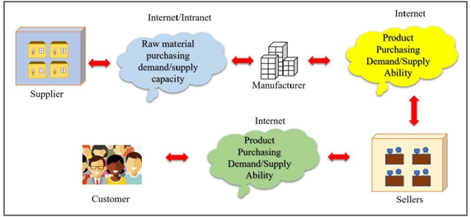

Figure 1 Information transmission in the supply chain topology in the situation of business independence.

Information sharing promotes dynamic selection and coordination across business entities in the supply chain while also increasing their flexibility. Currently, there is a dearth of comprehensive, group-wide, multidirectional, and open mutual supervision amongst business entities in supply chains, and supervisory relationships are generally unilateral and localized. The overall operational effectiveness of supply chains is greatly impacted by this disjointed approach to information flow and sharing.

When the topological structure of supply chain information transmission is analysed, it becomes clear that the industry is fragmented and that companies function independently of one another, depending on different platforms for conducting transactions. Due to the restricted insight into the entire supply chain structure and activities caused by this compartmentalized approach, corporate entities' integration, coordination, and information sharing are subpar. As a result, initiatives to raise the effectiveness of individual companies frequently come at the expense of supply chain efficiency as a whole.

It's vital to remember that while information sharing is essential, supply chain processes cannot be completely optimized by it alone. Mutual coordination between business organizations based on shared supply and demand information as well as external environmental elements is the key to achieving true operational efficiency [5]. The internal supply chain is transformed into a coordinated and interactive entity that is capable of flexible adaptability through agile and real-time dynamic coordination among multiple corporate entities in response to internal and external changes. Customers at the end of the supply chain are viewed in this perspective as external subjects, emphasizing the comprehensive character of supply chain responsiveness and coordination.

A business-to-business (B2B) transaction occurs online in Figure 1 between suppliers and manufacturers as well as between manufacturers and sellers. A business-to-consumer (B2C) transaction occurs online between sellers and customers. As can be seen from Figure 1, each supply chain's business contents are merely notional supply chains while the businesses are operating independently of one another. Every type of business content has a separate platform for doing transactions. The whole business is finished when every business entity's transaction on the business transaction platform is finished. The supply and demand data pertaining to its own business activities is the only ones that each corporate organization is able to access or concentrate on. Every corporate entity finds it challenging to understand the entire structure and functioning of the supply chain. A supply chain system like this has inadequate coordination and integration skills, as well as insufficient information exchange. Every company goes above and above to increase the effectiveness of its own corporate content. The ultimate consequence is a decline in the supply chain's overall efficiency.

The Idea of Blockchain Application to Realize the Sharing of Supply Chain Information

As a decentralized ledger technology, blockchain presents a viable way to accomplish transparency and openness in information sharing. Supply chain business organizations can be efficiently merged into a single system where they can safely share interests and oversee one another by utilizing blockchain technology. By protecting against malicious alteration or destruction of essential information, this application of blockchain technology enables coordinated management across multiple corporate entities along the supply chain and allows for frictionless sharing of information.

Blockchain technology's intrinsic qualities—such as its immutability and decentralization—make it a prime choice for improving the integrity and transparency of supply chain processes. Blockchain enables businesses to work together more efficiently, maintaining the accuracy and reliability of supply chain-related data. Furthermore, by enabling supply chain participants to make defensible decisions based on trustworthy data, blockchain technology enhances corporate selection procedures and promotes scientific decision-making.

It is crucial to recognize that even if the original Bitcoin blockchain invented the technology, there are some restrictions when using it in particular settings. For example, the fundamental openness and transparency of blockchain information may cause sensitive information to leak. Furthermore, storage redundancy problems could arise from the decentralized storage of blockchain data by authentication subjects, making data management procedures in supply chain activities more difficult.

When building a production enterprise's supply chain utilizing blockchain technology, the private network of the company or the internet are used. Only authorized supply chain business entities are able to participate in the blockchain system, preventing unrelated users from interfering with system operations and lowering the possibility of bad users banding together to fabricate supply chain data.

Various business entities are motivated to safeguard their own interests while simultaneously working to improve the overall efficiency of the supply chain by providing accurate information and actively participating in the supervision of supply chain operations within the framework of the supervision mechanism and competitive environment.

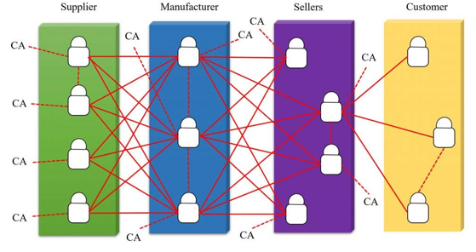

Figure 2 Blockchain-based production enterprise supply chain architecture.

The supply chain architecture of a blockchain-based production company is shown in Figure 2. Within this architecture, 'CA' stands for a certificate authority, and every manufacturer, seller, and supplier functions as a separate certification centre, verifying the veracity of supply chain data and the reasoning behind decision-making procedures. The authentication centre is more erratic and unpredictable than other company units. Therefore, this article normally does not treat 'customer' as an authentication centre unless specifically stated otherwise. Customers can, however, use approved channels to access supply chain data.

This architecture uses a decentralized blockchain operating system to store supply chain data instead of having distinct business units store them independently. Supply chain data is accessible to all authorized corporate entities, lowering the possibility of incomplete and asymmetric information. By guaranteeing the authenticity and trackability of supply chain data, this method enhances operational effectiveness and expedites information response times in the supply chain.

The hierarchical model of supply chain information flow based on blockchain comprises five distinct layers, each serving a specific function in the transmission and processing of supply chain data:

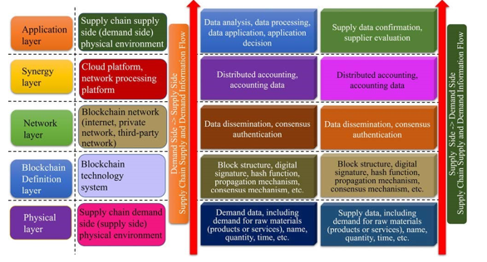

Figure 3 Blockchain-based supply chain information flow hierarchical model.

1) Entity Layer: This layer depicts the actual surroundings in which supply chain entities function. It includes both the supply and demand sides, where basic data on raw materials (i.e., goods and services) in the supply chain are generated and sent.

2) Blockchain Definition Layer: This layer defines the blockchain technology system, including block structure, digital signature principles, hash algorithms, data dispersed over the network, and data validity and authenticity authentication methods. This layer creates the required definitions prior to information about supply and demand entering the network.

3) Network Layer: This layer facilitates the interchange of supply chain business content by defining the network infrastructure that the blockchain is built upon. Peer-to-peer supply chain data dissemination is made possible, and data transmission can be authenticated by authentication topics.

4) Collaboration Layer: This layer deals with various data types produced during supply chain activities and is in charge of managing and storing data related to supply chain operations. Additionally, it coordinates the exchange of external source data required for supply chain business analysis and decision-making, logging on the blockchain the source and information summary of these outside resources.

5) Application Layer: This layer controls how recipients use the data that senders deliver, including verifying, evaluating, and drawing conclusions from the data in accordance with those conclusions. It includes things like information analysis, corporate entities other than the recipient responding, and supply chain system decision-making.

Every tier in the hierarchical architecture plays a part in the efficient exchange, handling, and application of supply chain data in the blockchain-driven system. These layers enable the smooth flow of information throughout the supply chain network by clearly defining roles and responsibilities, guaranteeing efficiency, security, and transparency in supply chain operations.

1. **METHODOLOGY**

3.1 Information Block Recording Method for Internal and External Data Sources in the Supply Chain

The Organizational Framework and Evaluation of Multisource Information Both Within and Beyond the Supply Chain

The processes of supply-side or demand-side selection, business activity decision-making, and business activity traceability are all included in supply chain business decision-making activities. The supply chain system receives a ton of information from these actions. Both external data introduced from sources outside the system and internal data generated by the system's operations make up the data used for supply chain business decision-making activities.

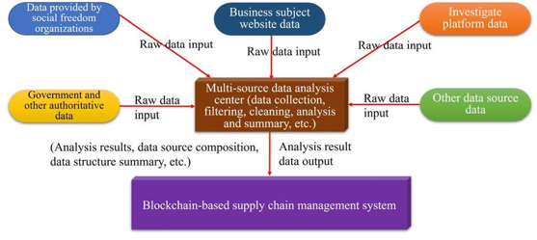

Figure 4 Data processing situation of the external multisource data analysis centre of the supply chain based on blockchain.

Business entities have access to blockchain-based supply chain system data within the supply chain system. However, outside parties that are a part of the supply chain are only allowed to contribute data to the blockchain system; they are not allowed to access the blockchain data itself. Figure 4 shows the composition of multisource data both inside and outside the supply chain.

Complex processes like data collecting, filtering, cleansing, analysis, and summarization are involved in managing data from many external sources outside the supply chain. It is impractical to expect any supply chain corporate organization to handle these tasks on its own, though. This article suggests the creation of a multisource data analysis centre centred on supply chain companies as a solution to this problem. This centre would handle the processing of multisource data pertaining to business management of the supply chain.

There are several categories into which external multisource data related to supply chain business management can be divided. These include data from online sources provided by businesses, data from government and authoritative organizations, data from social organizations, data from investigation platforms, and data from other sources. Multiple sources may be involved in each category, underscoring the complexity of data management within the context of the supply chain. By making it easier to process and integrate these various data sources, utilizing blockchain technology improves the supply chain's integration capabilities.

Figure 4 shows the data processing workflow of the blockchain-based supply chain's external multisource data analysis centre.

3.2 Multisource Data Information Block Recording Approach

This paper proposes that storing block summaries on the blockchain is an effective solution to manage external multisource data in the supply chain. When a demander requests external multisource data related to a supplier's transaction during a transaction, the system sends a request to the supply chain's external multisource data analysis centre.

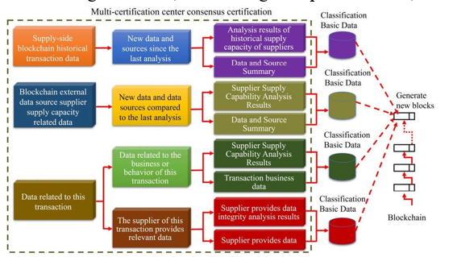

Figure 5 Internal and external multisource data block records and block chain generation methods for supply chain management

The block record and blockchain creation process for supply chain management data from both internal and external multisource sources is shown in Figure 5. According to predetermined guidelines, the external multisource data analysis centre receives information collecting requirements from the supply chain management system certification organizations. Subsequently, the centre selects the dataset for data processing and collecting, providing each supply chain certification authority with pertinent outcome information. The appropriate supplier result information is broadcast by the certification body with accounting privileges in the blockchain system, where it is verified and disseminated by additional authentication subjects, such as the demander.

With the supply side of the supply chain business chosen as an example, Figure 6 shows how to generate block records and blockchains for both internal and external multisource data. Four types of supply chain management materials exist, albeit the exact demands will determine which type is used. To maintain separate storage of blockchain and supply chain management data, different categories of fundamental data are saved in distinct data storage bodies and mapped with the block body of the relevant block in the blockchain. This division makes it easier to administer a blockchain effectively, guaranteeing its manageability, ease of building, and modest capacity. By using matching mapping relationships, it also upholds the logical integrity between the supply chain management data system and the blockchain system.

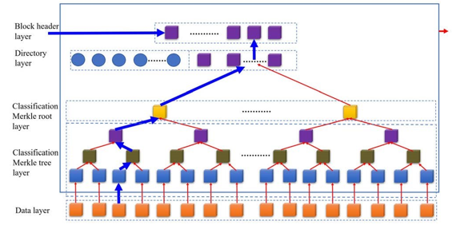

Figure 6 A virtual connection network between information of a business entity in a blockchain-based supply chain.

The matching blockchain system structure needs to be flexible due to the distinct data format and storage of blockchain-based supply chain management systems. The following five sections make up the data format that this article suggests for supply chain management systems based on blockchain technology.

The supply chain ecosystem is illustrated by a virtual connecting network between business entity information in Figure 6, which highlights the interconnectedness enabled by blockchain technology. Taking this into consideration, this article suggests the block data format for the blockchain-based supply chain management system, which is composed of the subsequent five sections.

1) DATA LAYER

This refers to supply chain management-related information.

2) CLASSIFIED MERKEL TREE BODY LAYER

This means that the data of different classifications constitute different Merkle trees; these Merkle trees do not intersect with each other, and this layer stores the Merkle tree body.

3) CLASSIFIED MERKEL TREE ROOT LAYER

Unlike the classification Merkle tree block layer, this layer stores the root of each different Merkle tree.

4) DIRECTORY LAYER

This layer builds a directory according to the basic data corresponding to the Merkle tree roots of different classifications. The layer is set according to actual needs and a Merkle root is calculated for every N classification Merkle roots.

5) BLOCK HEADER LAYER

Every Merkle root in the directory layer is given a total Merkle root by the system. This tree root will be included in the block header along with the version number of this pivot block, the timestamps, the consensus authentication parameters, and the hash value of the previous block's block header.

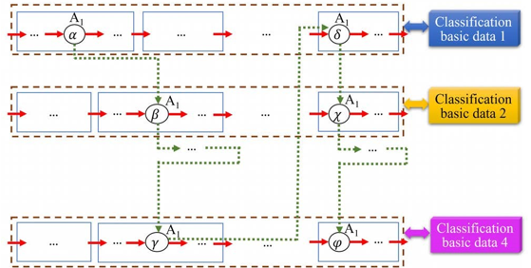

FIGURE 7. Data structure of blocks in a blockchain-based supply chain management system

3.3 Supply Chain System Information Block Link Generation Approach

In this work, we propose to create virtual link relationships between the basic data that share a mapping relationship with a blockchain block and the directory layer of each block. To further associate data with mapping relationships across various blocks, it proposes building comparable virtual connection relationships within each block's directory layer. Through the virtual link between directory layers within blocks, pertinent basic data with mapping relationships to the blockchain can be quickly found by utilizing hash function indications. This structure is the link network of fundamental data, produced by virtual links. The blockchain can be used to obtain basic data's storage location and structure, even if access rights are specified for data kept in the categorization body.

The order of business activities is followed by the operation process in a supply chain that revolves around a producing organization. As a result, the operational business process of the supply chain is in line with the process of producing business entity information. The virtual link network between business subject information in a supply chain based on blockchain technology is depicted in Figure 8. The set of fundamental data for every block is represented by the solid box. It's crucial to remember that blocks representing fundamental information from many classes could be identical. The diagram illustrates the topology of the virtual link network for business topic data, emphasizing the linkages that are represented in the directory layer records of every block in the blockchain.

The data of business entity A1 is arranged in Figure 7 into virtual linkages based on a predetermined sequence using several basic data classifications. These links provide distinct basic data attributes of the same corporate entity in several roles-based categorization.

Business Content Information Virtual Link Network

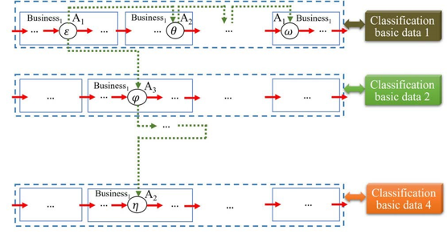

FIGURE 8. Virtual connection network between supply chain business content information based on blockchain

The blockchain-based virtual connection network connecting supply chain business content information is shown in Figure 8. The business content 'Business' in this illustration presents information from the same fundamental dataset for classification, creating virtual links in a predetermined order. In a similar vein, the fundamental information linked to Business1's business content within the same block creates virtual links in a different order. The creation of linkages to underlying data matching to the blockchain is made possible by these virtual links.

3.4 VALUE ANALYSIS OF BLOCKCHAIN

The benefits of current supply chain business entities joining the supply chain system for transactions are rather stable over time and should be discounted when evaluating their business transaction benefits, according to the suggested method's analysis of the aforementioned content. The main factors that determine a firm's market share are its rate of return and its corporate entities' attitude toward risks. In the field of supply chain management, blockchain technology is becoming increasingly generally accepted and utilized. The current business content management system and the market mechanism are not able to completely fulfill the cost-free liberalization of business entities entering a supply chain system.

The examination of the aforementioned content by the recommended technique indicates that the benefits of present supply chain business entities joining the supply chain system for transactions are pretty consistent over time and should be disregarded when evaluating their business transaction benefits.

A company's market share is mostly determined by its rate of return and the way its corporate entities handle risk. The use of blockchain technology in supply chain management is expanding in acceptance and use. The market mechanism and the current business content management system are unable to fully realize the cost-free liberalization of business entities joining a supply chain system.

1. **Experimental results**

Supply chain management can greatly benefit from the application of blockchain technology, which also provides answers to a number of issues that arise in contemporary logistics. Utilizing the decentralized ledger system of blockchain technology, businesses may improve security, traceability, and transparency across the whole supply chain network.

Improving transaction and product movement visibility and transparency is one important outcome of implementing blockchain. Every transaction and data exchange using blockchain is documented in an unchangeable, tamper-proof ledger, giving stakeholders instant access to correct data. Because of this transparency, there is less chance of fraud, counterfeiting, and mistakes, which builds confidence among supply chain participants and makes decision-making easier.

Data and transactions in the supply chain are more securely stored when blockchain technology is used. Blockchain reduces the possibility of data manipulation, unauthorized access, and cyberattacks by using cryptographic algorithms and consensus procedures. In addition to safeguarding sensitive data, this increased security encourages better integrity and trust throughout the supply chain ecosystem, which eventually results in more resilient and efficient operations.

1. 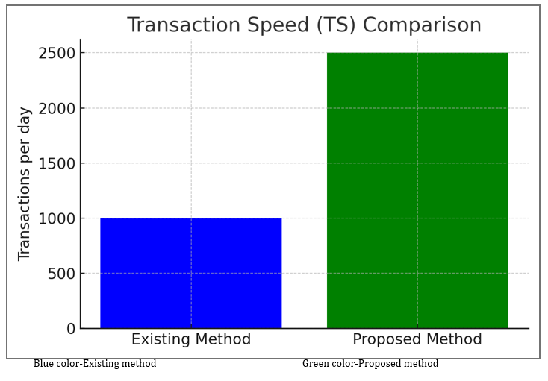

Figure 10 Transaction Speed (TS) Comparison

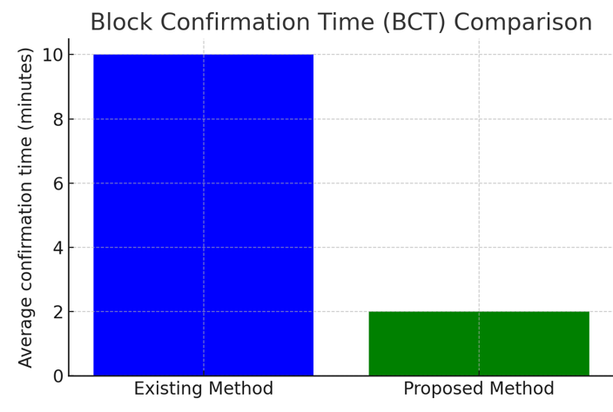

Figure 11 Block Confirmation Time(BCT) Comparison

Transaction Speed (TS): The ability of the blockchain to process transactions within a given timeframe. It's crucial for supply chain applications to process transactions quickly to maintain real-time tracking.

Formula: TS=Time Period/Total Transactions

Block Confirmation Time (BCT): The time it takes for a block to be added to the blockchain. In supply chains, faster block confirmation times can lead to more up-to-date tracking information.

Formula: BCT=Total Blocks/Total Time to Confirm Blocks

Cost Efficiency (CE): Measures the cost of conducting transactions on the blockchain versus the savings or value generated by enhanced supply chain management.

Formula: CE=(Total Savings from Supply Chain Improvements−Total Blockchain Operation Costs)/ Total Blockchain Operation Costs

Security Level (SL): The ability of the blockchain to protect against unauthorized access.

5.1 Transaction Velocity (TS)

Trial Current Approach Suggested Approach Transaction Speed (TS) 1000–2500Blue hue: Current technique: Green hue: Suggested approach The comparison picture for Transaction Speed (TS) displays the daily transactions for the current approach and the suggested blockchain approach. The number of transactions per day is increased from 1,000 to 2,500 using the suggested way.

The number of transactions per day grows from 1,000 to 2,500 with the proposed blockchain technique. This suggests that the system's ability to handle transactions has significantly improved, which may result in increased throughput and efficiency for processes that depend on these transactions.

5.2 Crucial Entry Moment

The Block Confirmation Time (BCT) comparative graphic depiction shows the average confirmation time in minutes for both the current system and the proposed blockchain solution. The recommended method drastically cuts the block confirmation time from 10 minutes to just 2 minutes. The proposed blockchain solution can significantly reduce block confirmation time, from 10 minutes to only 2 minutes. This decline points to a more efficient process for recording and verifying transactions.

1. **conclusion**

The entity layer, blockchain definition layer, network layer, collaboration layer, and application layer make up the five-layer model of supply chain information flow that is created by the suggested study. With this method, data from the supply chain is divided into two groups: data connected to external sources and data from internal processes. It also proposes a block recording method for multisource data information that is located both inside and outside the chain, and it shows the composition and data structure properties of the chain's exterior and internal data sources. The whole blockchain is connected by hash function indications. This forms the basis for the study of a virtual link generating example and the recommendation of a virtual link structure for the creation of blockchain-related data. Openness and transparency of data are characteristics of the conventional blockchain.

**References**

1. I. A. Omar, R. Jayaraman, M. S. Debe, H. R. Hasan, K. Salah, and M. Omar, ‘‘Supply chain inventory sharing using ethereum blockchain and smart contracts,’’ IEEE Access, vol. 10, pp. 2345–2356, 2022.
2. M. Du, Q. Chen, J. Chen, and X. Ma, ‘‘An optimized consortium blockchain for medical information sharing,’’ IEEE Trans. Eng. Manag., vol. 68, no. 6, pp. 1677–1689, Dec. 2021.
3. T. Guggenberger, A. Schweizer, and N. Urbach, ‘‘Improving interorganizational information sharing for vendor managed inventory: Toward a decentralized information hub using blockchain technology,’’ IEEE Trans. Eng. Manag., vol. 67, no. 4, pp. 1074–1085, Nov. 2020.
4. H. Xiao, W. Zhang, W. Li, A. T. Chronopoulos, and Z. Zhang, ‘‘Joint clustering and blockchain for real-time information security transmission at the crossroads in C-V2X networks,’’ IEEE Internet Things J., vol. 8, no. 18, pp. 13926–13938, Sep. 2021.
5. D. Lee and M. Song, ‘‘MEXchange: A privacy-preserving blockchainbased framework for health information exchange using ring signature and stealth address,’’ IEEE Access, vol. 9, pp. 158122–158139, 2021.
6. Y. Wang, A. Zhang, P. Zhang, and H. Wang, ‘‘Cloud-assisted EHR sharing with security and privacy preservation via consortium blockchain,’’ IEEE Access, vol. 7, pp. 136704–136719, 2019.
7. X.Yang,M.Li,H.Yu,M.Wang,D.Xu,andC.Sun,‘‘Atrustedblockchainbased traceability system for fruit and vegetable agricultural products,’’ IEEE Access, vol. 9, pp. 36282–36293, 2021.
8. P. K. Wan, L. Huang, and H. Holtskog, ‘‘Blockchain-enabled information sharing within a supply chain: A systematic literature review,’’ IEEE Access, vol. 8, pp. 49645–49656, 2020.
9. H. Chai, S. Leng, Y. Chen, and K. Zhang, ‘‘A hierarchical blockchainenabled federated learning algorithm for knowledge sharing in internet of vehicles,’’ IEEE Trans. Intell. Transp. Syst., vol. 22, no. 7, pp. 3975–3986, Jul. 2021.
10. M. Baza, N. Lasla, M. M. E. A. Mahmoud, G. Srivastava, and M. Abdallah, ‘‘B-ride: Ride sharing with privacy-preservation, trust and fair payment atop public blockchain,’’ IEEE Trans. Netw. Sci. Eng., vol. 8, no. 2, pp. 1214–1229, Apr. 2021.
11. P. Alemany, R. Vilalta, R. Munoz, R. Casellas, and R. Martinez, ‘‘Evaluation of the abstraction of optical topology models in blockchain-based data center interconnection,’’ J. Opt. Commun. Netw., vol. 14, no. 4, pp. 211–221, Apr. 2022.
12. X. Zhang and X. Chen, ‘‘Data security sharing and storage based on a consortium blockchain in a vehicular ad-hoc network,’’ IEEE Access, vol. 7, pp. 58241–58254, 2019.
13. Z. Yu, D. Xue, J. Fan, and C. Guo, ‘‘DNSTSM: DNS cache resources trusted sharing model based on consortium blockchain,’’ IEEE Access, vol. 8, pp. 13640–13650, 2020.
14. L. Tan, K. Yu, N. Shi, C. Yang, W. Wei, and H. Lu, ‘‘Towards secure and privacy-preserving data sharing for COVID-19 medical records: A blockchain-empowered approach,’’ IEEE Trans. Netw. Sci. Eng., vol. 9, no. 1, pp. 271–281, Jan. 2022.
15. H. Sheng, S. Wang, Y. Zhang, D. Yu, X. Cheng, W. Lyu, and Z. Xiong,
16. ‘‘Near-online tracking with co-occurrence constraints in blockchain-based edge computing,’’ IEEE Internet Things J., vol. 8, no. 4, pp. 2193–2207, Feb. 2021.
17. L. Liu, J. Feng, Q. Pei, C. Chen, Y. Ming, B. Shang, and M. Dong, ‘‘Blockchain-enabled secure data sharing scheme in mobile-edge computing: An asynchronous advantage actor–critic learning approach,’’ IEEE Internet Things J., vol. 8, no. 4, pp. 2342–2353, Feb. 2021.
18. M.A.Rahman,M.M.Rashid,M.S.Hossain,E.Hassanain,M.F.Alhamid, and M. Guizani, ‘‘Blockchain and IoT-based cognitive edge framework for sharing economy services in a smart city,’’ IEEE Access, vol. 7, pp. 18611–18621, 2019.
19. X. Jiang, F. R. Yu, T. Song, Z. Ma, Y. Song, and D. Zhu, ‘‘Blockchainenabled cross-domain object detection for autonomous driving: A model sharing approach,’’ IEEE Internet Things J., vol. 7, no. 5, pp. 3681–3692, May 2020.
20. Z. Shahbazi and Y.-C. Byun, ‘‘Blockchain-based event detection and trust verification using natural language processing and machine learning,’’ IEEE Access, vol. 10, pp. 5790–5800, 2022.
21. D. Na and S. Park, ‘‘Blockchain-based dashcam video management method for data sharing and integrity in V2 V network,’’ IEEE Access, vol. 10, pp. 3307–3319, 2022.